COM161 Problem Solving for Computing Practical Lab
Practical Lab 3
The tasks below are based on the gap notes entitled Decision Structures and Boolean Logic. In several cases, you are directed to programs on Blackboard. In each case, you should save a copy of the code to your own folder before editing.

1. A copy of the program test_average.py, which was used as an example in the notes, is available on Blackboard.
(a) Modify the code so that it takes the average of four scores rather than three and congratulates the user if s/he gets a score of over 70.
(b)The code currently has a number of weaknesses. It only accepts integer input, and it may return the result to a large number of decimal places. Modify the code to remove these two issues.
(c)Modify the code so that it congratulates the user for a high score and prints a stern warning if the score is too low.
2. Write a program which follows the logic of Figure 2 of the notes. It should ask the user to enter the temperature, and then print one of the two statements depending on the input.
3. A copy of the program grader.py, which was used as an example in section 4 of the notes, is available on Blackboard.
Modify the code to ask the user to enter their marks (out of 100) on three pieces of coursework for a module. The final mark for the module is the average of the three coursework marks. The program should ask for the three marks and display the overall mark and the grade.
4. Assume the variables a=2, b=4 and c=6. Which of the following statements are true?
a==4 or b>2
6<=c and a>3
1!=b and c!=3
a>=-1 or a<=b
not(a>b)
Check your answers using the Python interpreter in interactive mode.

5. A hardware company sells nails at 10p each. It charges £2 for postage and packing irrespective of how many nails are ordered, but it also gives discount for bulk purchase as follows:
Number of nails bought | Discount
1-50 | 0%
51-100 | 10%
100-200 | 20%
201 or more | 25%

Write a program that asks the user how many nails they want to buy. The program should then display the percentage discount that will be applied, the cost order before postage and packing, and the total bill including postage and packing.
6. The short program password.py, which was discussed in the notes, is available on Blackboard. In the lecture, you were also shown The Bridge of Death from Monty Python. Modify password.py to ask the user three questions;
1. Their name
2. Their quest
3. Their favourite colour.
The answer to 1 is allowed to be anything. But the answer to 2 must be ‘thegrail’ and the answer to 3 must be ‘blue’
If either 2 or 3 are answered incorrectly the user is told that they are to be cast into the gorge of eternal peril, which is of course wholly appropriate.

7. Mark McCartney has written a short piece of Python code. Badly. Very badly. It is supposed to test eligibility for a bank loan. It doesn’t. It can be found on Blackboard (bugged_bank_loan.py). It a rather curt e mail his boss has contacted him saying that she has discovered 9 errors in the code and if he doesn’t ‘find them pretty flipping quick’ he’ll be ‘demoted to office tea-maker and pencil sharpener by the end of the week’. He needs help. Can you debug the code for him?
8. By drawing up an appropriate truth table show that not (P or Q) is logically equivalent to (not P) and (not Q).
9. What is the truth value of the proposition (not(X and Y) or Z) and (not (Q and P))? Where
P = Ballymena is in County Down,
Q = Light from the sun reaches earth in less than 10 minutes,
X = The UU has a campus in Belfast,
Y = Stephen Hawking is dead,
Z = It is the year 2020.
Check your answer using Python.

10. The short program square.py, available on Blackboard, draws a square of side length 100. Modify this code to allow the user to be asked to specify
(a) the side length
(b) the pen thickness
(c) the animation speed
(d) the pen colour
You may want to edit the code gradually, adding these features one at a time.
Can you modify the code to draw a hexagon instead?

11. Is it a leap year? Write a program which asks the user to enter the year and then displays whether the entered year is a leap year or not. The following criteria should be used:
(a) If a year is divisible by 100 and is also divisible by 400 it is a leap year.
(b) If a year is not divisible by 100, then it is a leap year if it is divisible by 4.
Hint: use the % operator.
12. Chinese years are assigned animals on a 12-year cycle. A full cycle is given below.

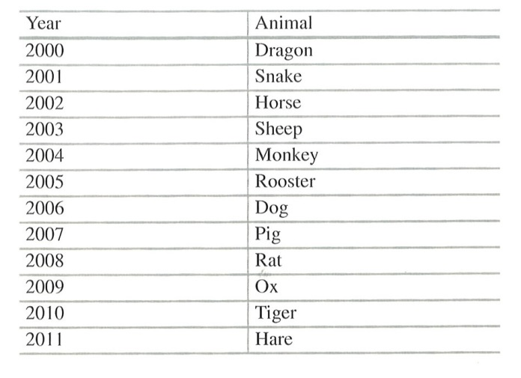

Write a program that reads a year from the user and displays the animal associated with that year. Your program should work for any year greater than zero, not just the ones listed in the table.

https://www.youtube.com/watch?v=0D7hFHfLEyk

